SNOWFLAKE DATA TRANSFORMATION
Existing:
Database: BIBLE_STUDY_DB
Schema: RAW
Warehouse: BIBLE_STUDY_WH
Table: BIBLE_READING_LOG
File format: BIBLE_CSV_FORMAT
Stage: BIBLE_STUDY_STAGE
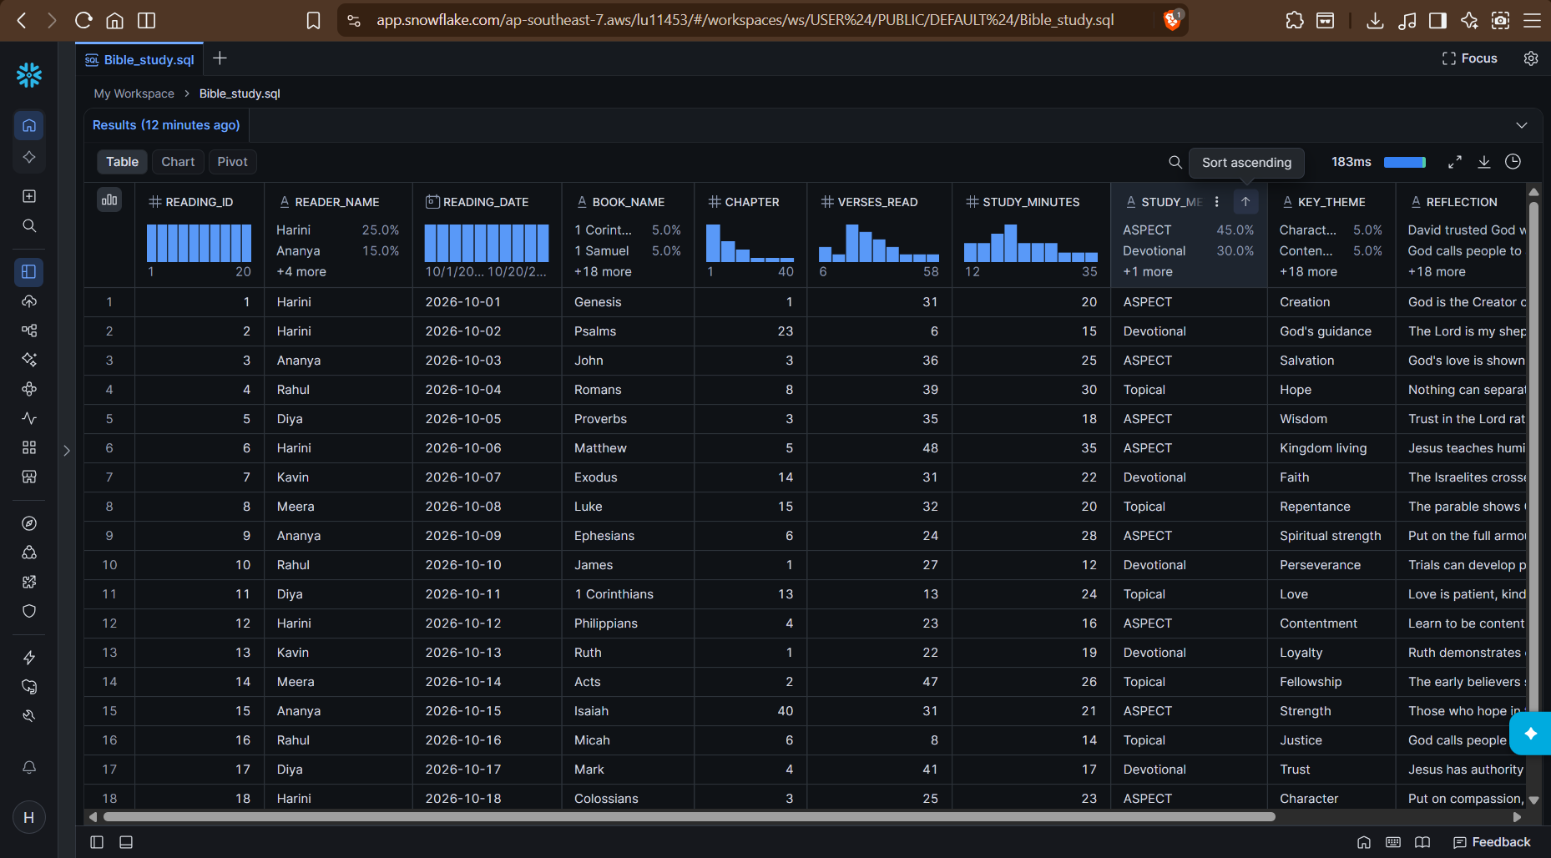
New tables:
- BIBLE_STUDY_CUSTOMERS
- BIBLE_STUDY_RESOURCE_ORDERS

2nd Table created(BIBLE_STUDY_CUSTOMERS):
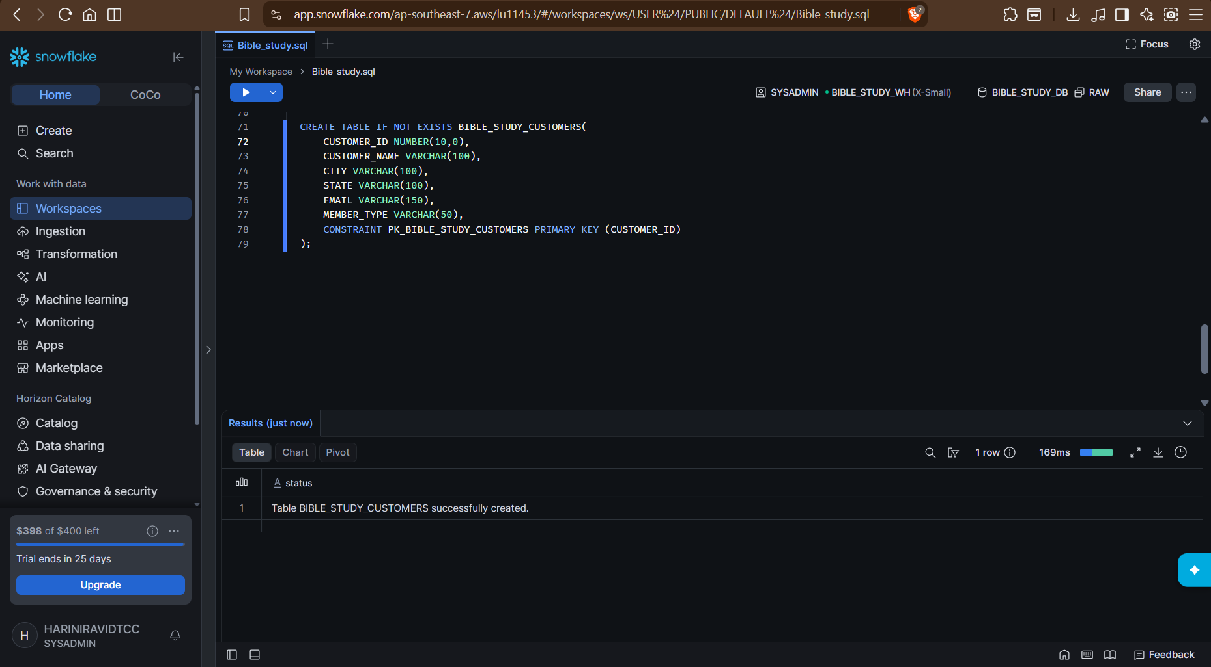
3RD table created(BIBLE_STUDY_RESOURCE_ORDERS):
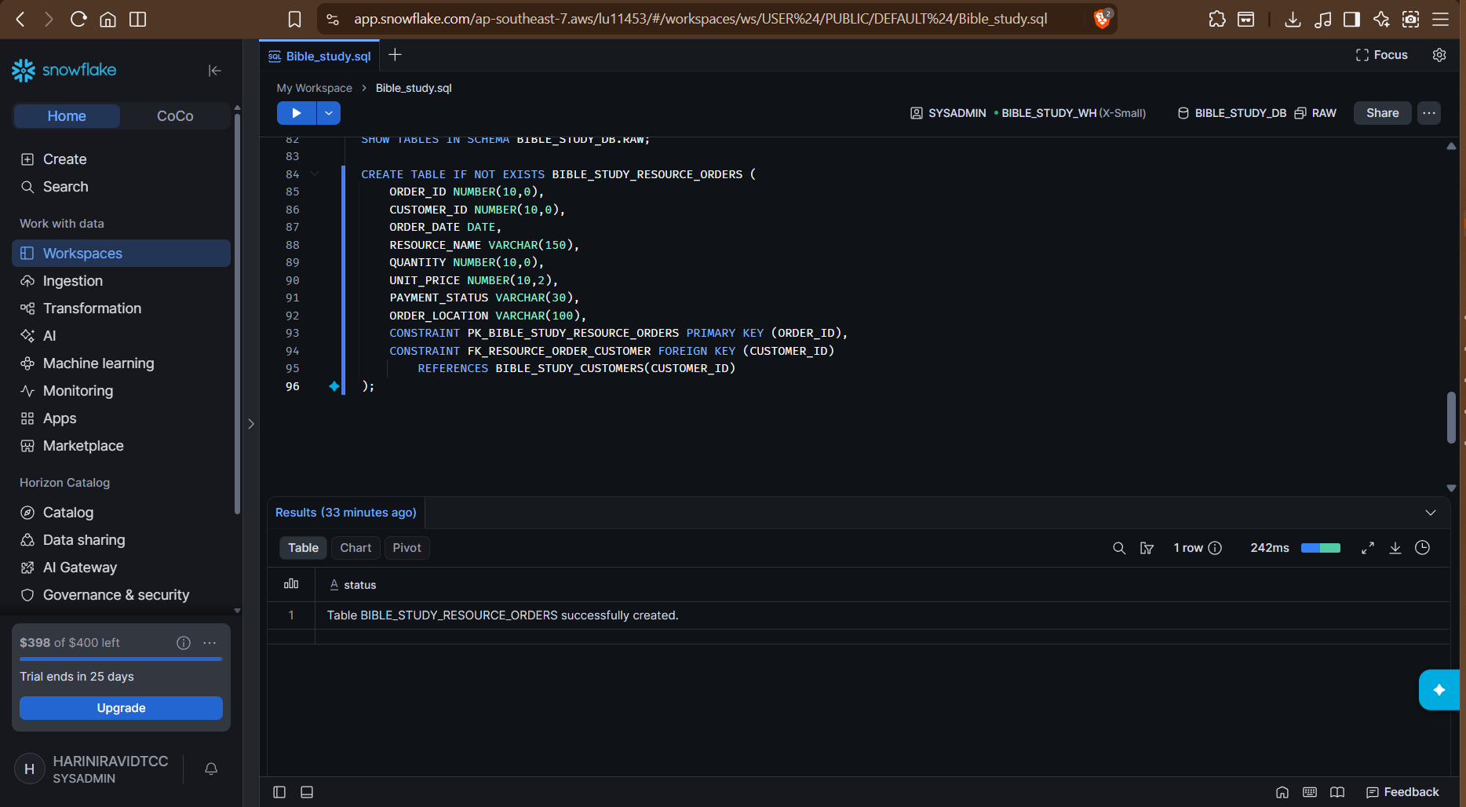

3 tables in same DB and same schema:
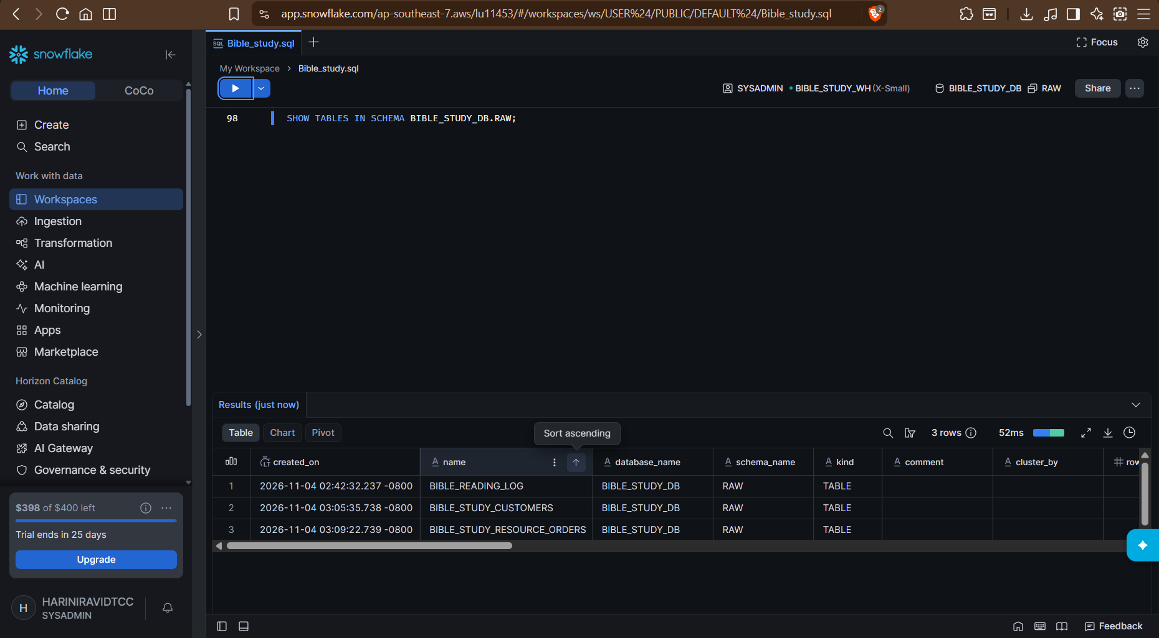
File format created:
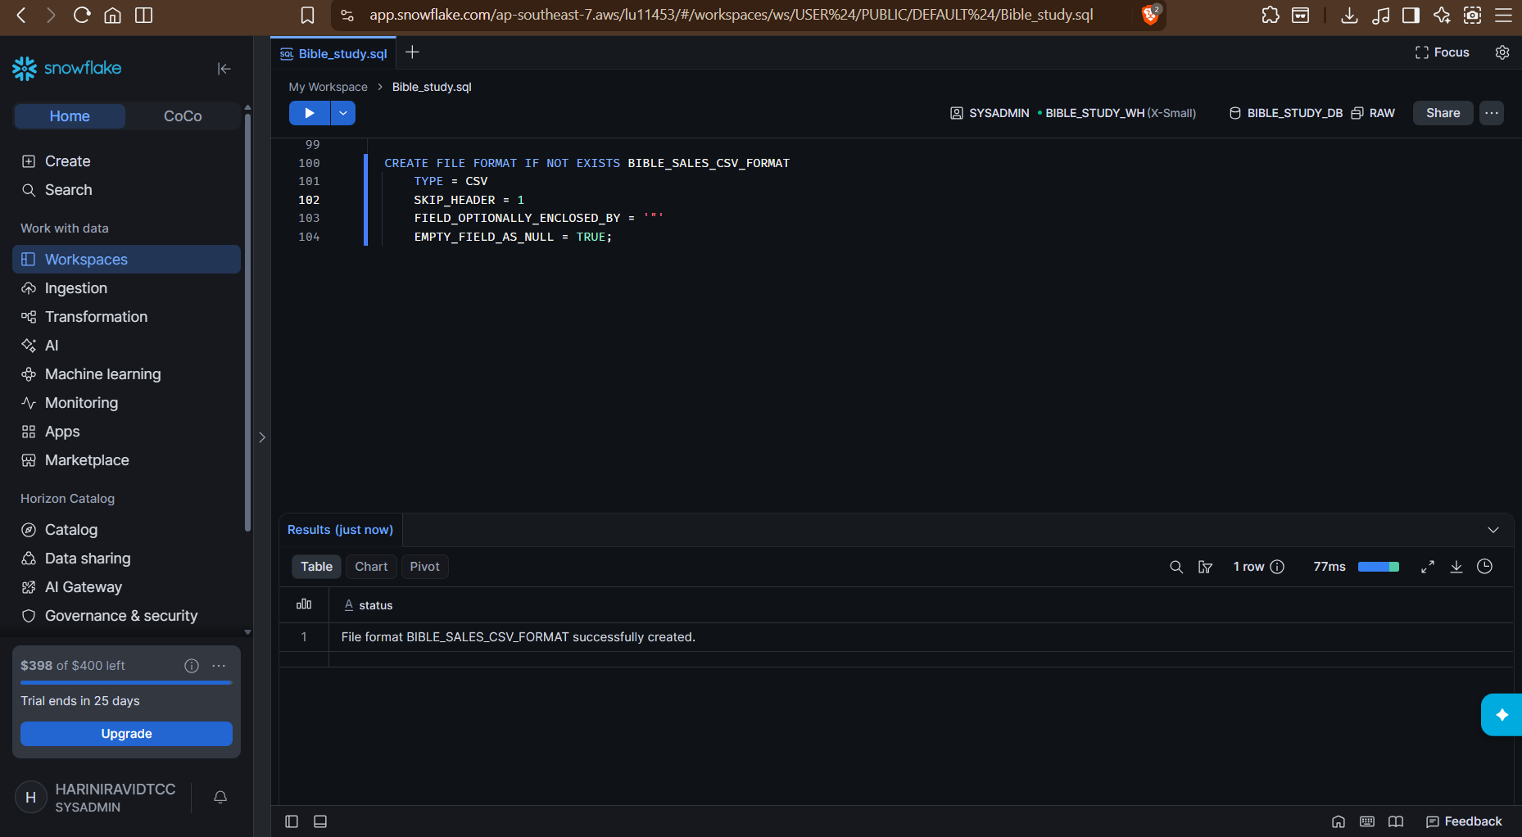

Stage created:
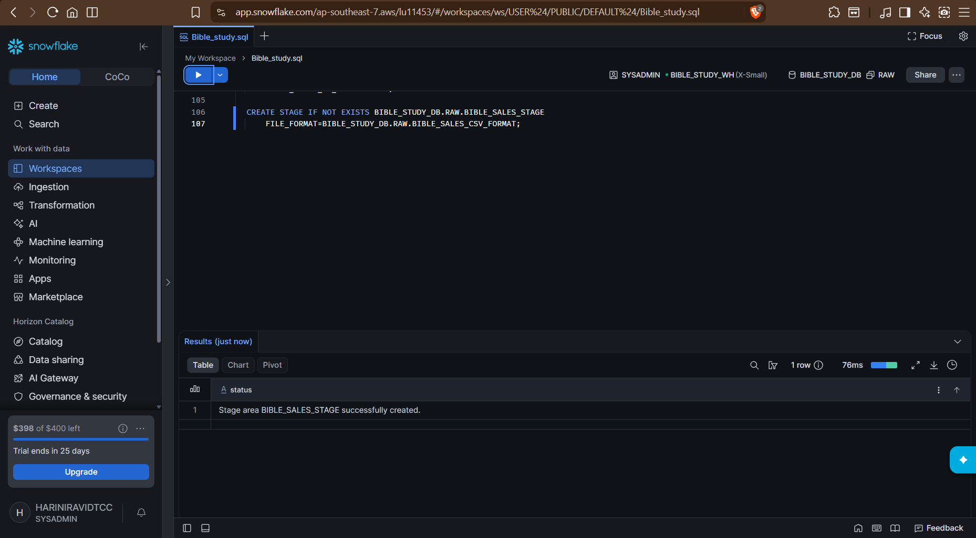
Stages in the DB’s schema:
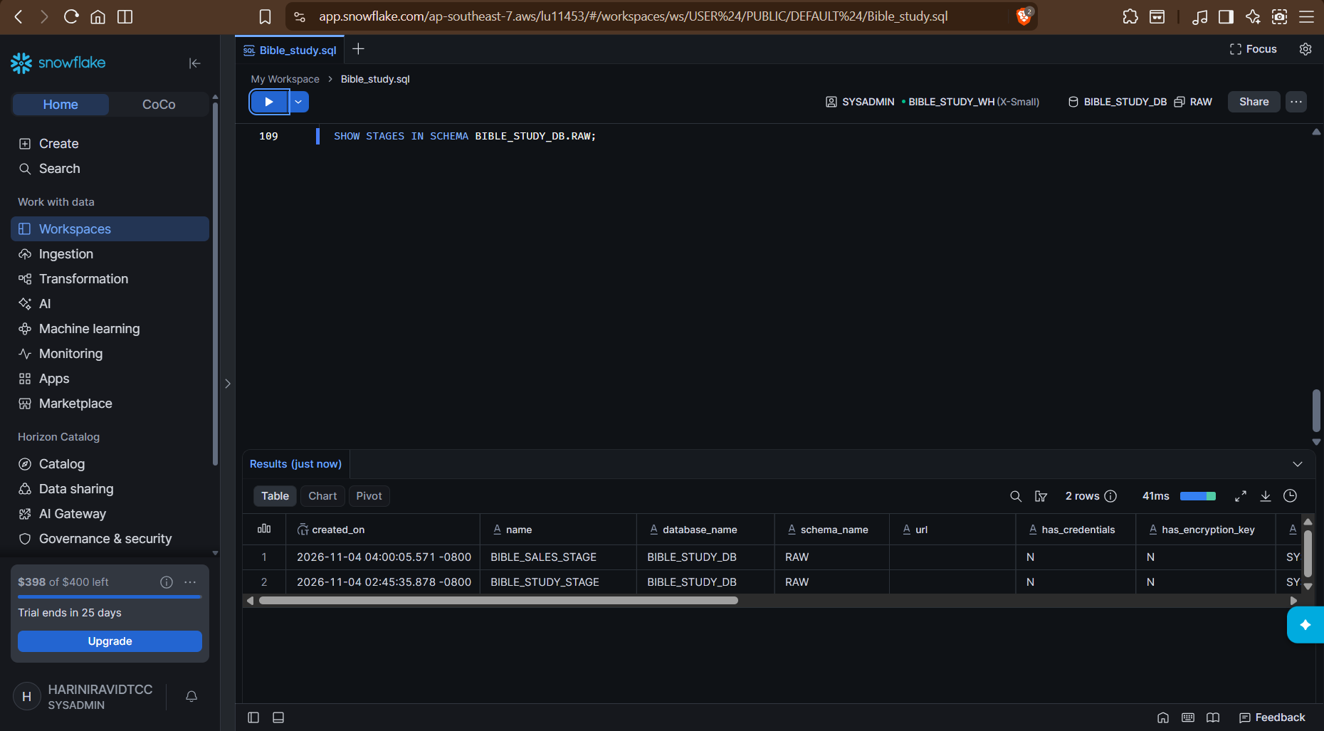
A stage can be created without creating a file format. It will use the default settings until and unless we specify while loading.
There are 3 different approaches:
Approach | How it works
Stage without fille format | Uses default settings unless specified during loading
Stage with file format | Associates a reusable file format with the stage
File format inside COPY INTO | Specifies formatting instructions only for that loading operation
Uploaded csv files in stage:
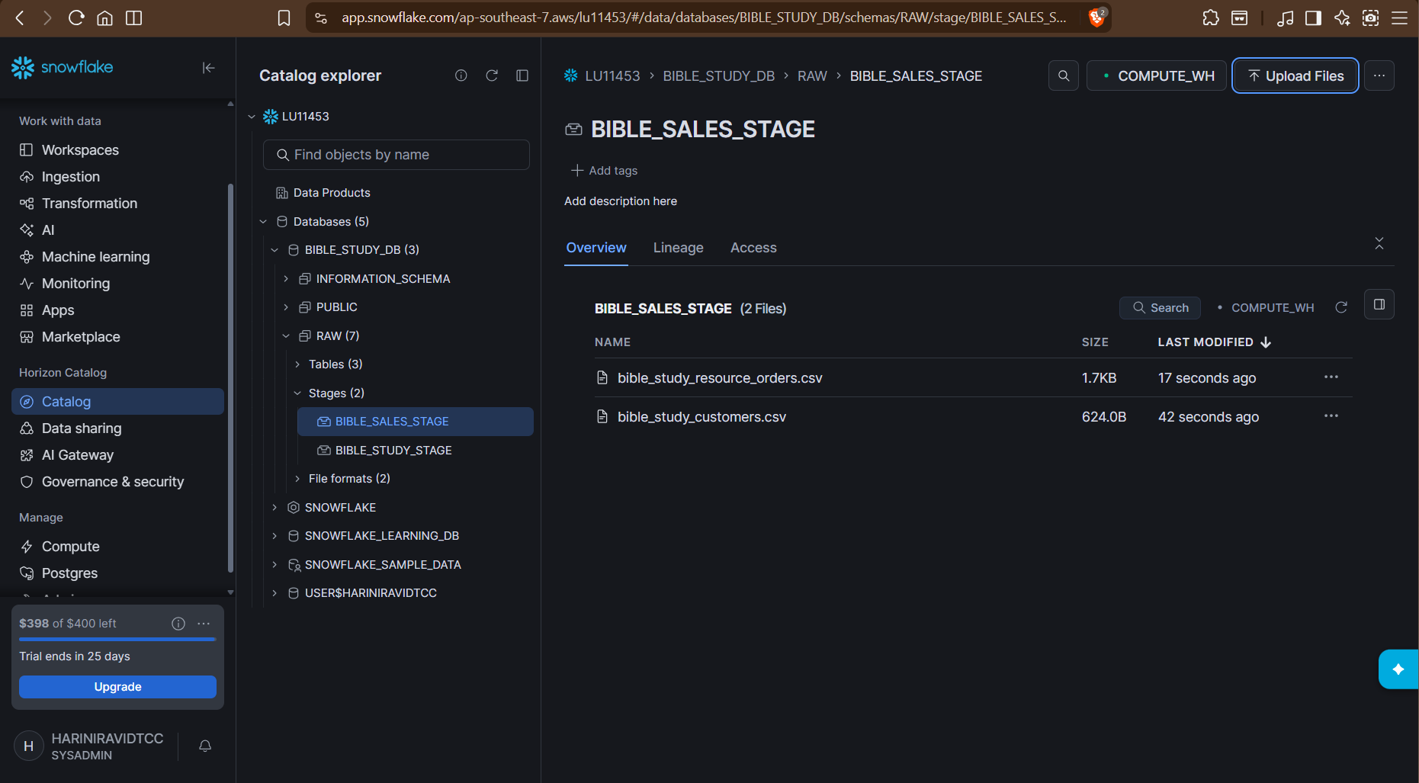
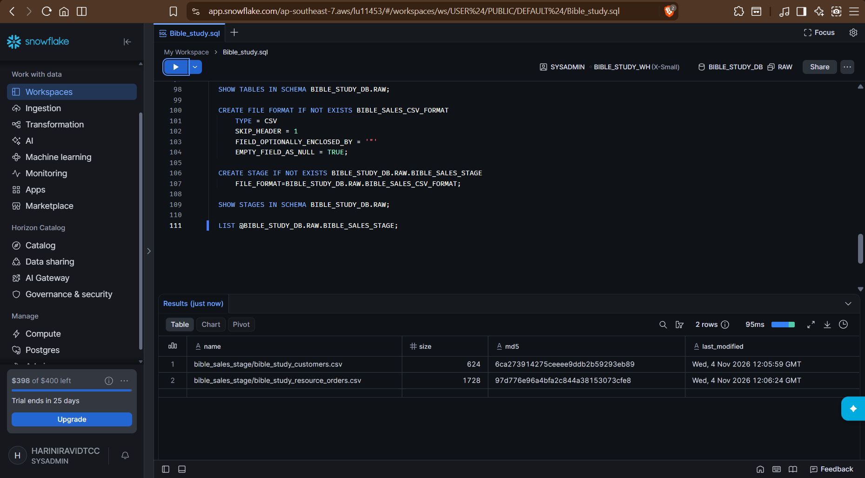

Copy from stage to table:
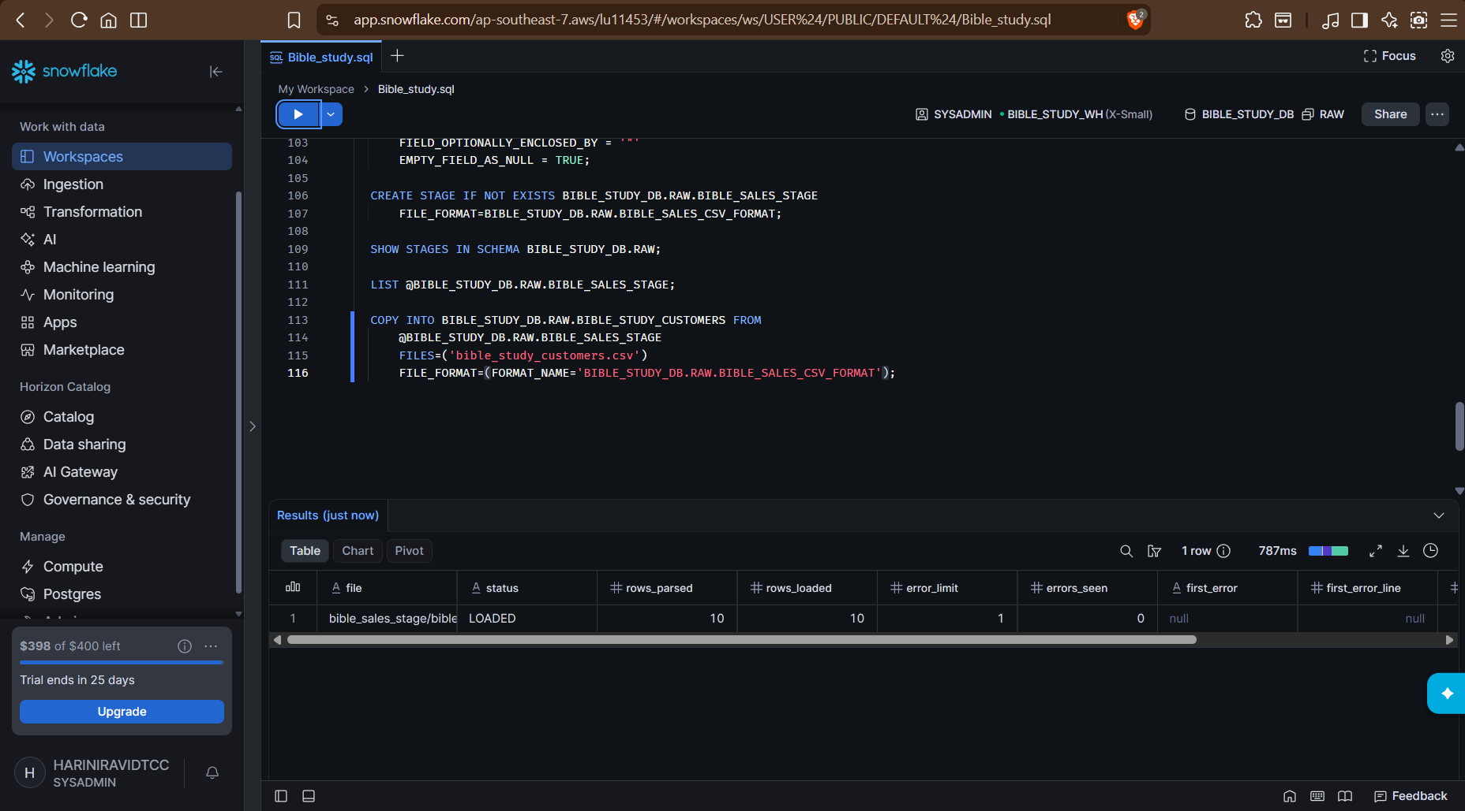
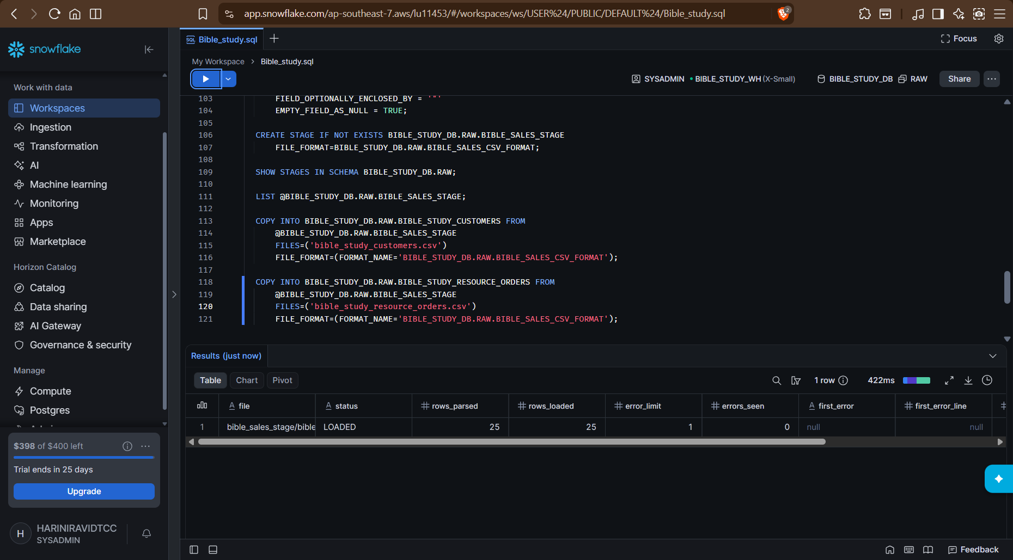

Selecting rows from tables:
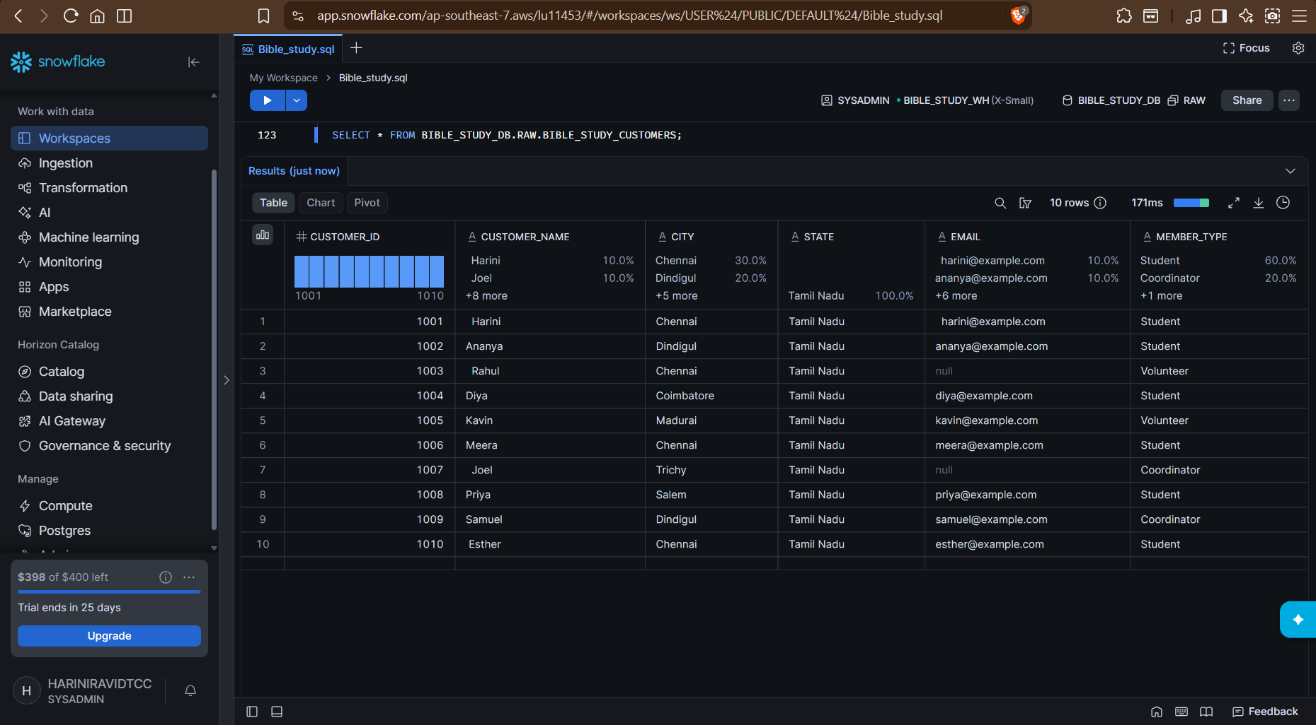
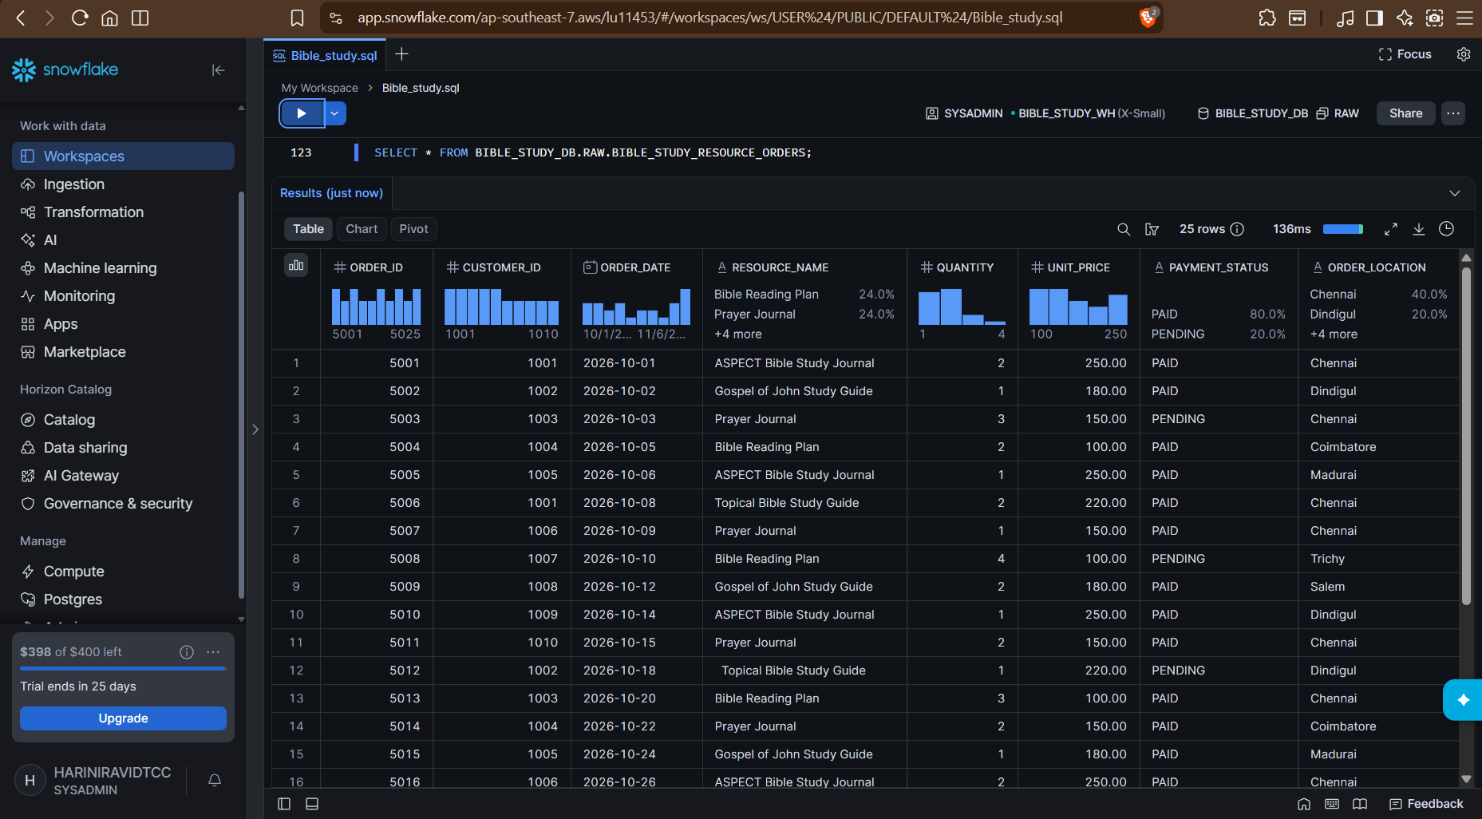

Count:
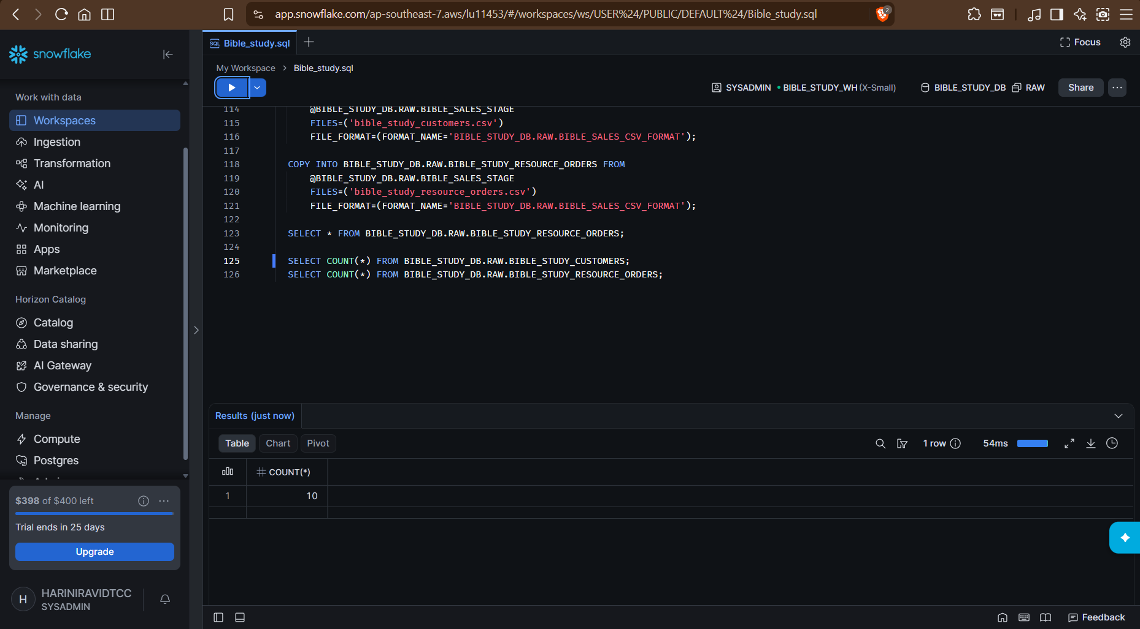
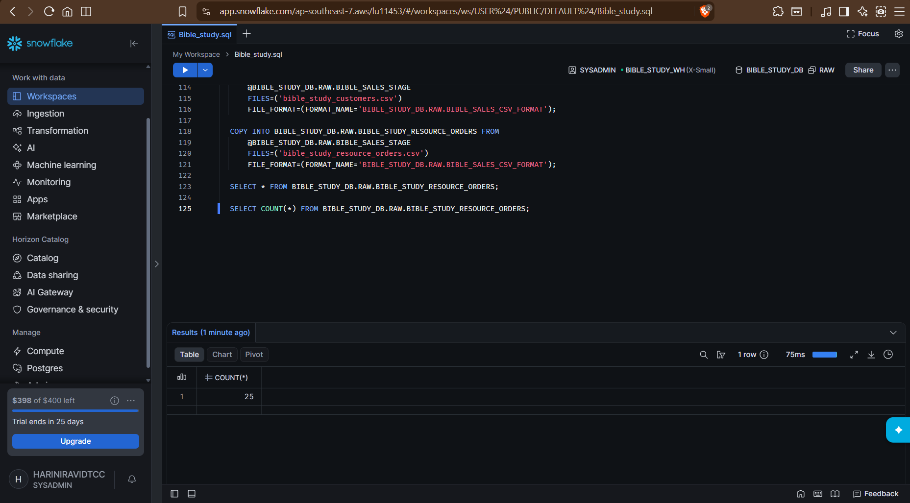

Coalesce, trim, upper function demonstration:
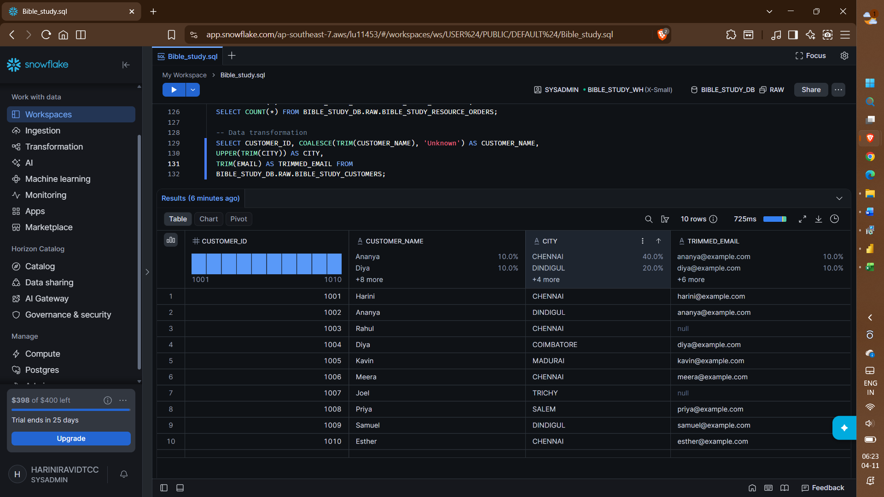
What I inferred?
If trim is used for a string with spaces, it removes the spaces.
If trim is used for null values, it will still be displayed as null.
If trim is used for empty data, it will still be empty even after trim.
New cleaned table created:
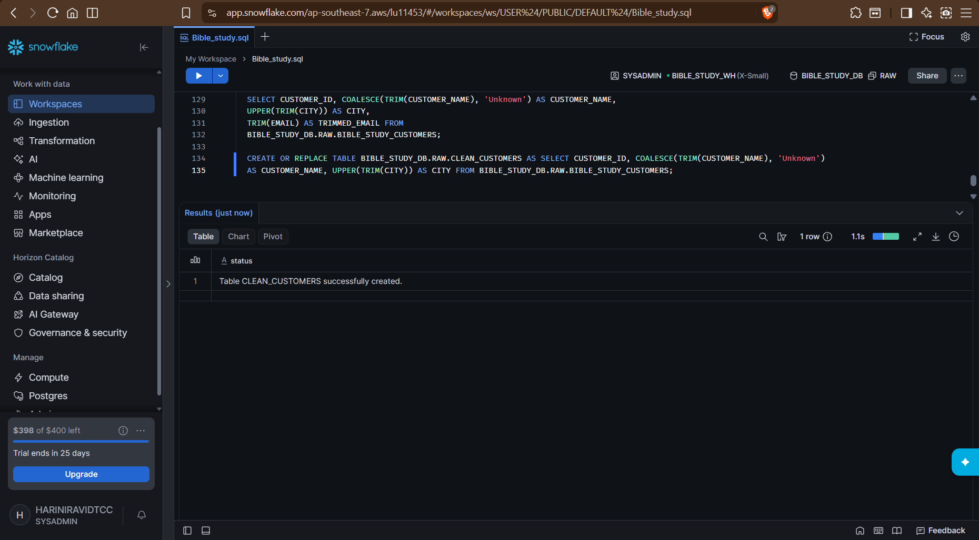

BIBLE_STUDY_DB.RAW.CLEAN_CUSTOMERS:
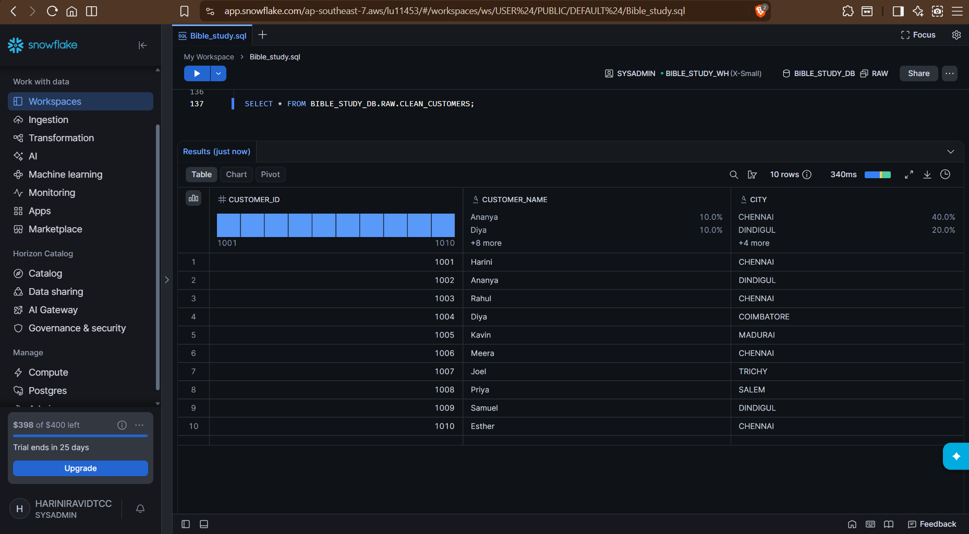
6 tasks:
- Display all orders:
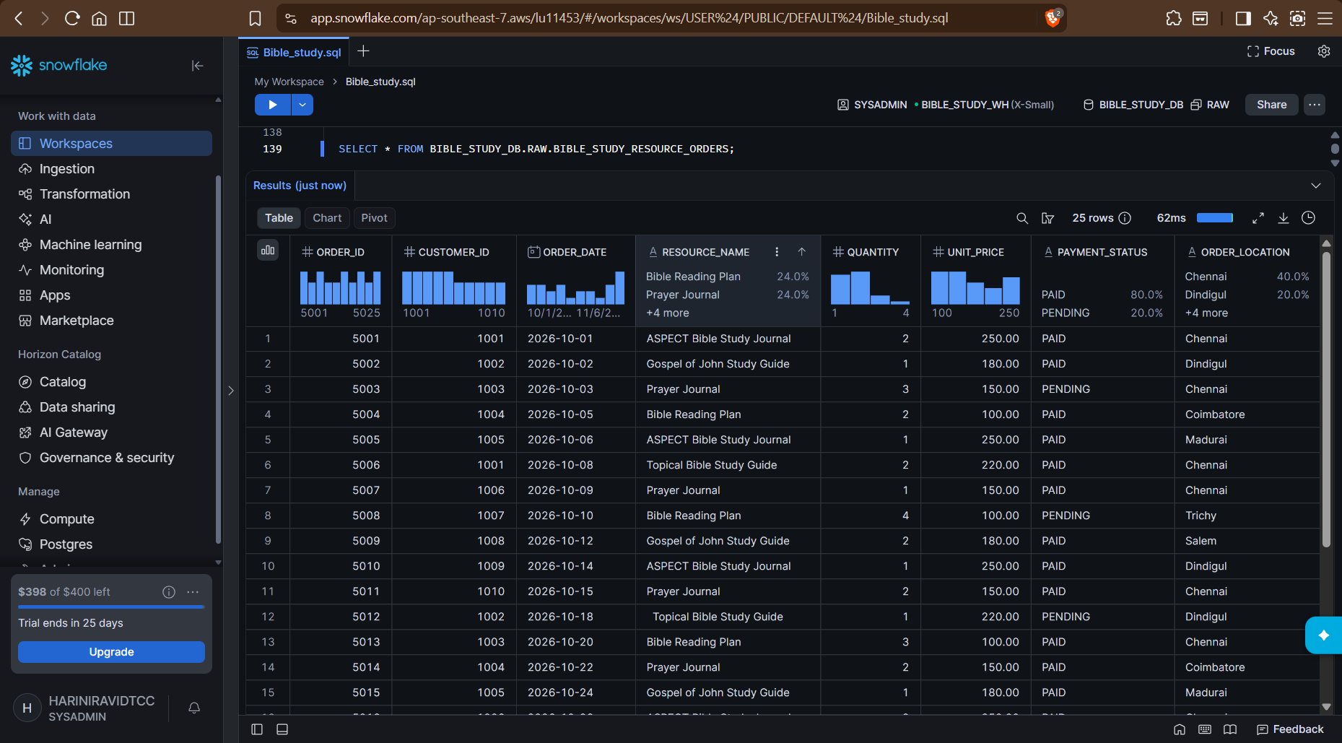

- Displaying orders from a particular location(Dindigul):
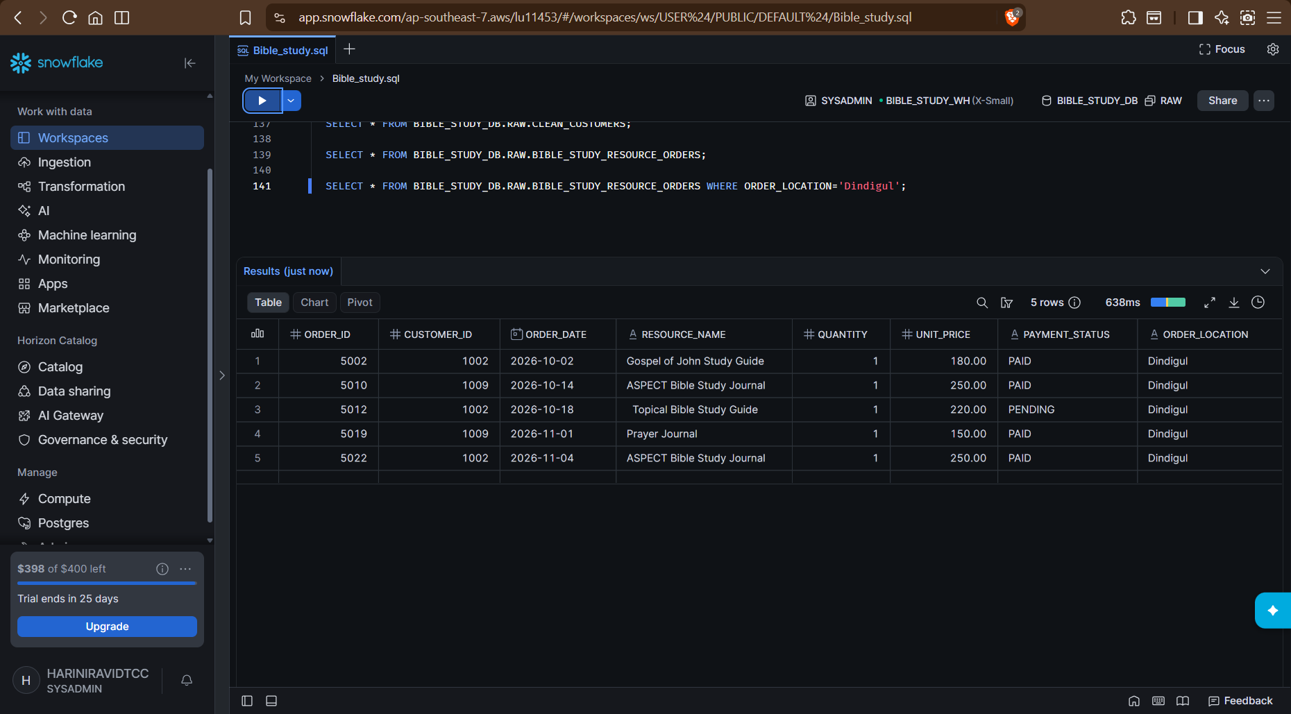
- Calculate total revenue:
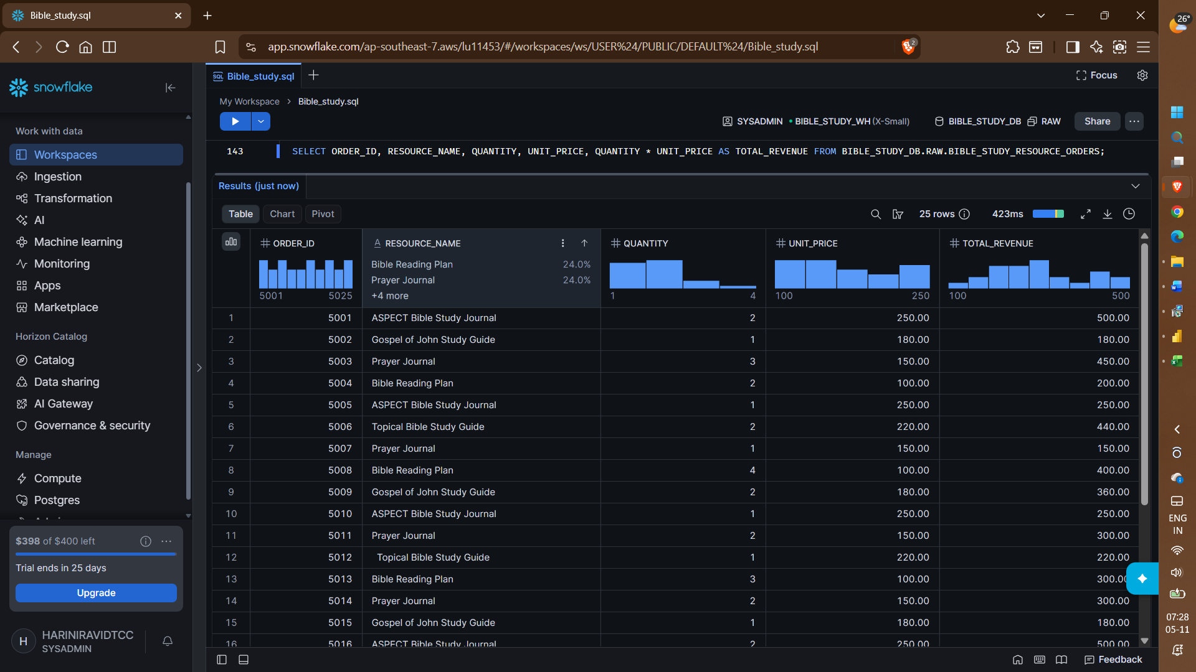

- Product(Resource_name) wise sales:
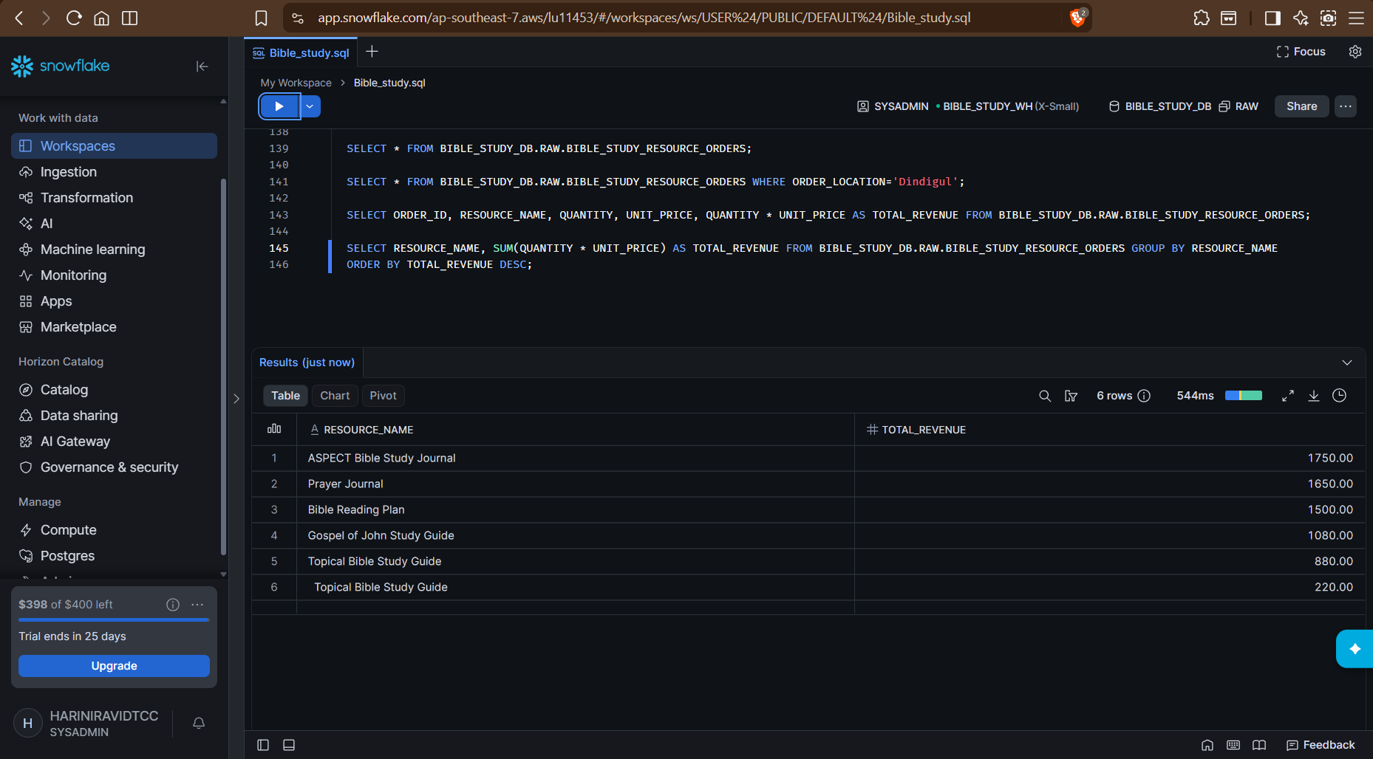
- Join operation on Bible_study_customers and Bible_study_resource_orders:
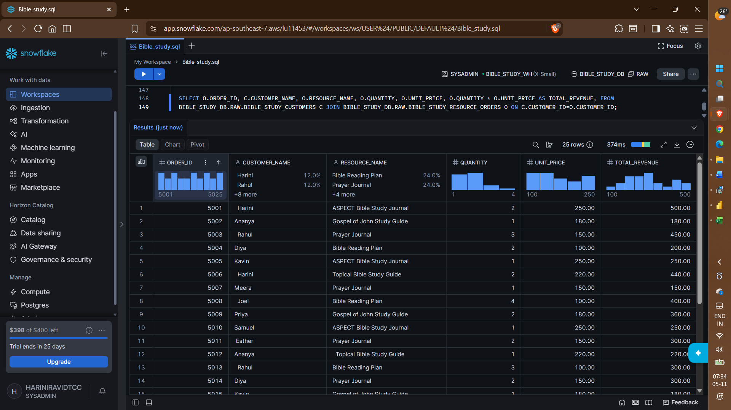

- Total sales by Customer ID:
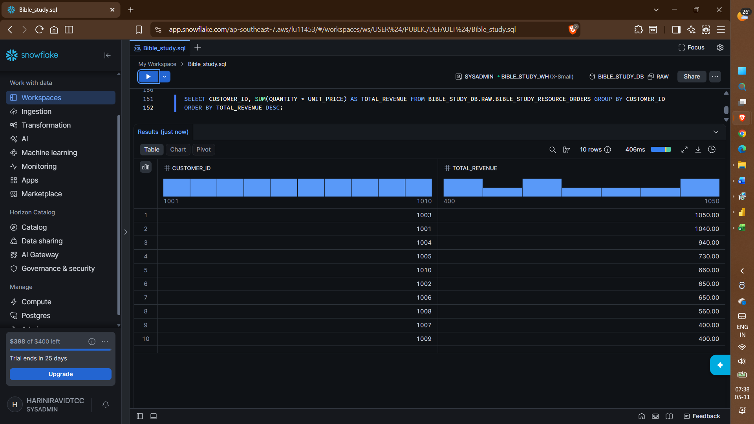

100000 randomly generated records:
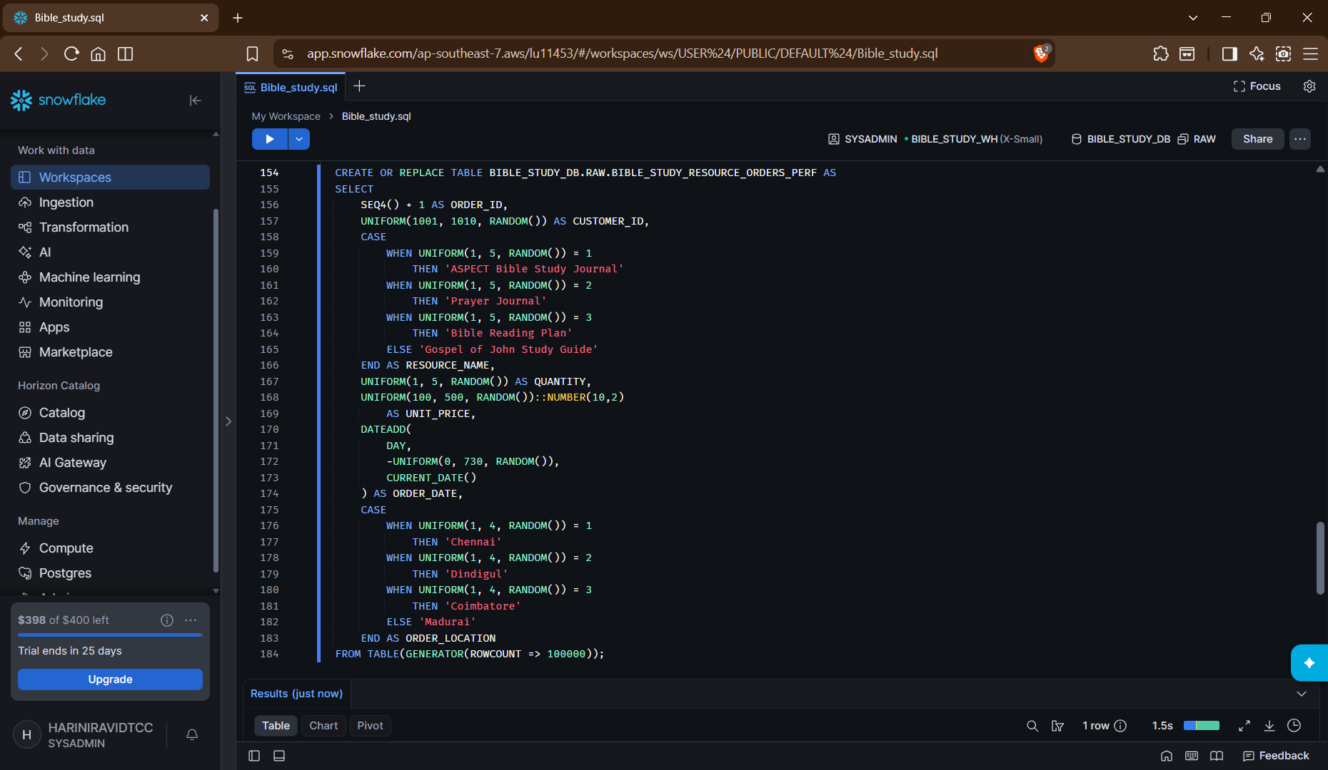
Function | Purpose
SEQ4() | Generates sequential numbers
UNIFORM() | Generates random numbers within a range
RANDOM() | Generates random values
DATEADD() | Adds or subtracts dates
CURRENT_DATE() | Returns today's date
CASE | Assigns values based on conditions
GENERATOR() | Generates the requested number of rows
CAST (::NUMBER) | Converts values into a specified data type
Count of rows:
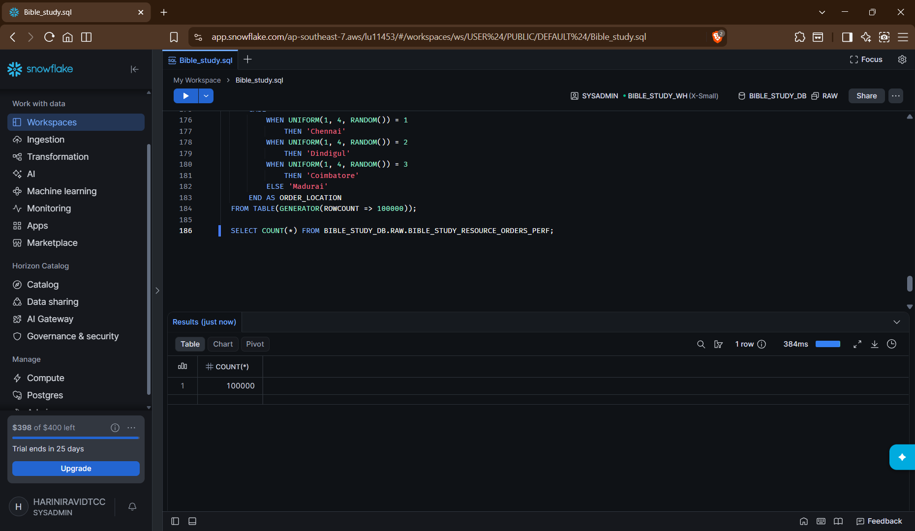

Query profile of previous command:
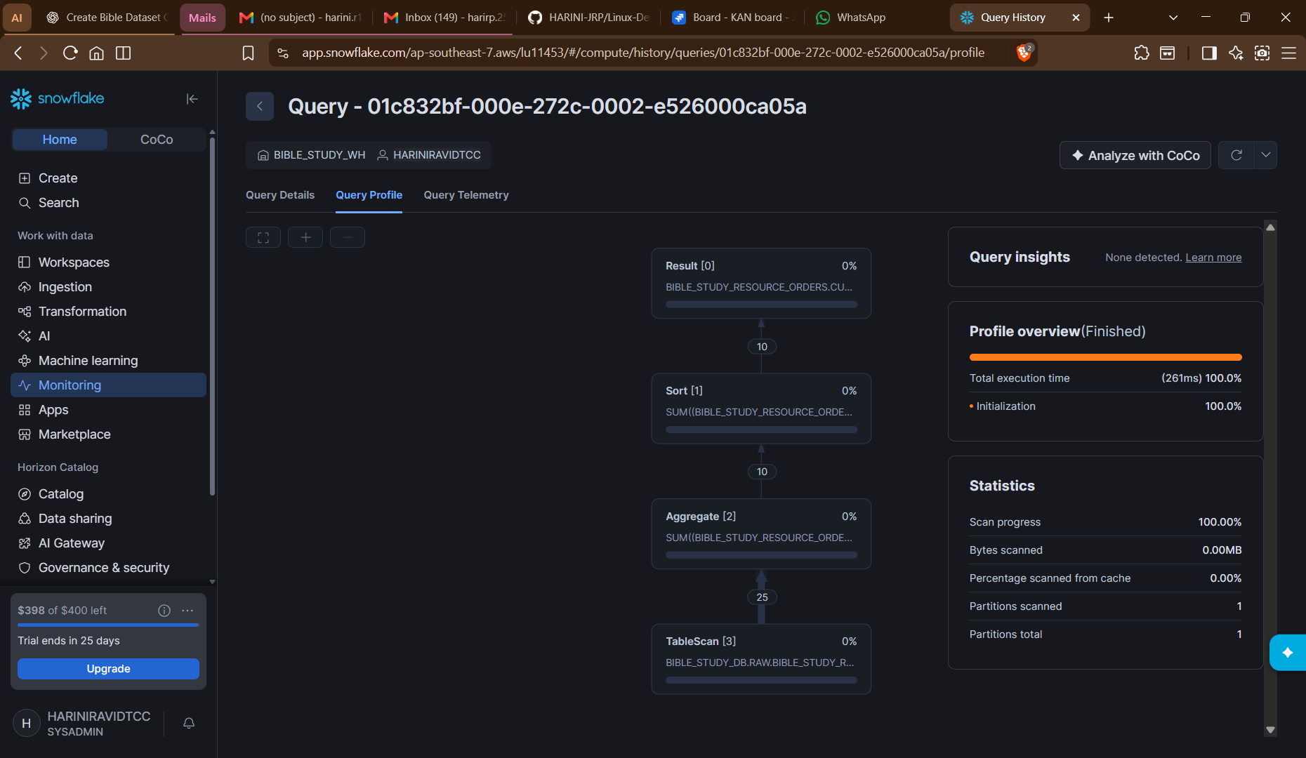
Year level filtering:
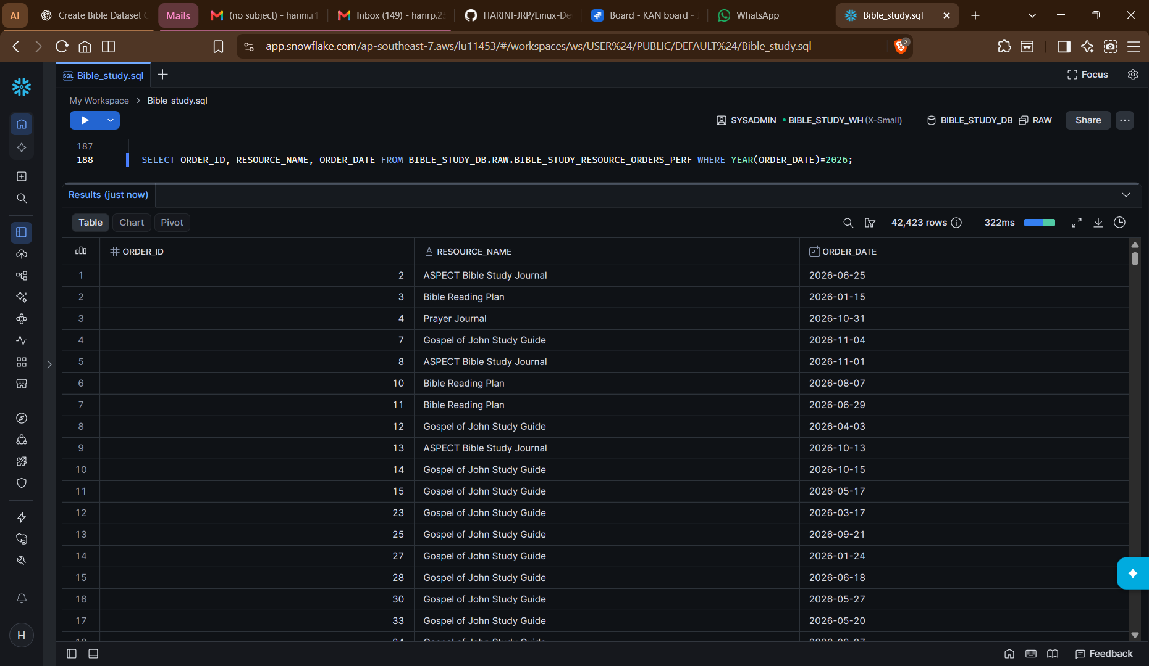

Date level filtering:
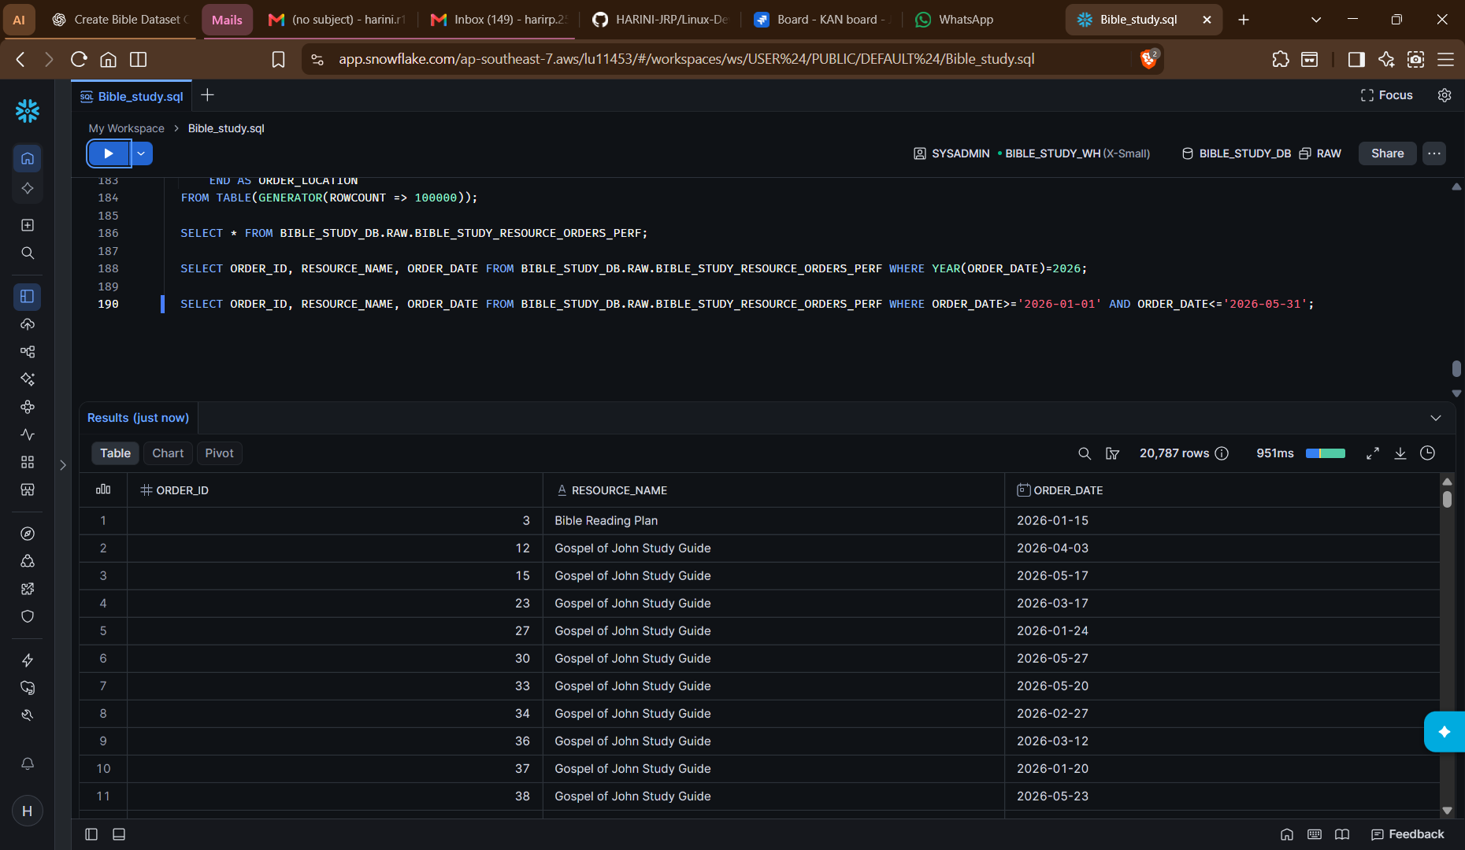
City wise sales:
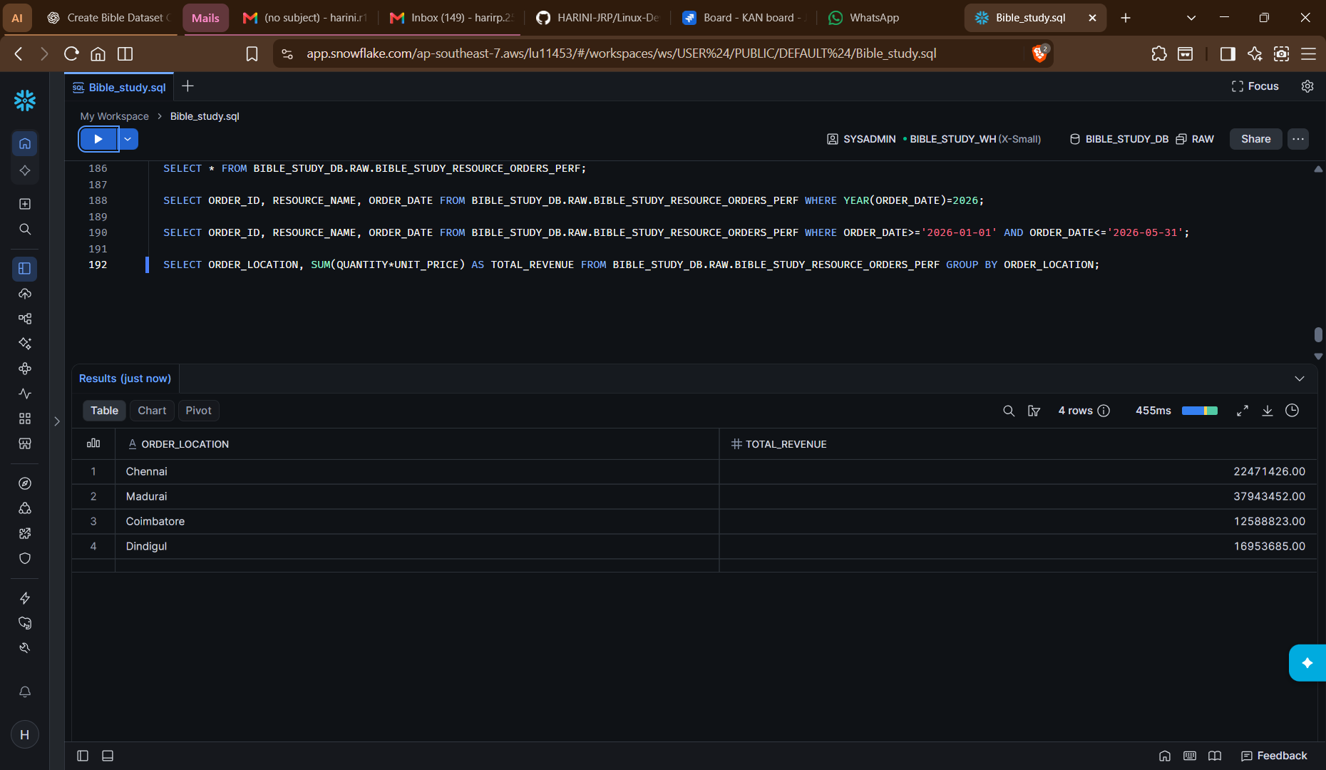
Deletion:
All tables, stages deleted and warehouse suspended.

